SIDDHARTH GROUP OF INSTITUTIONS :: PUTTUR
(AUTONOMOUS)
Siddharth Nagar, Narayanavanam Road – 517583

QUESTION BANK (DESCRIPTIVE)

Subject with Code: BEEE(18EE0240) Course & Branch: B.Tech-CIVIL
Year & Sem: I-B.Tech & II-Sem Regulation: R18
PART-A

UNIT –I
INTRODUCTION TO ELECTRICAL ENGINEERING
- (a) Define and Expain about ohms law. 5M
(b) Explain about passive elements in detail. 5M
- Three resistances of values 2Ω,3Ω and 5Ω are connected in series across 20V DC
supply. Calculate i) Equivalent resistance of the circuit. ii) The total current of the circuit.
iii) The voltage drop across each resistor. iv) The power dissipated in each resistor. 10M
3. Define and Expain about Energy sources in detail/Explain active elements in detail. 10M
4 (a) State and prove krichhoff law’s with an example 5M
(b)In the circuit shown below find i₁, i₂, i₃ by using Kirchhoff’s laws? 5M
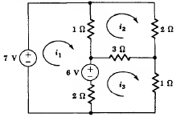
5.Find the current delivered by the source for the circuit shown in figure. 10M
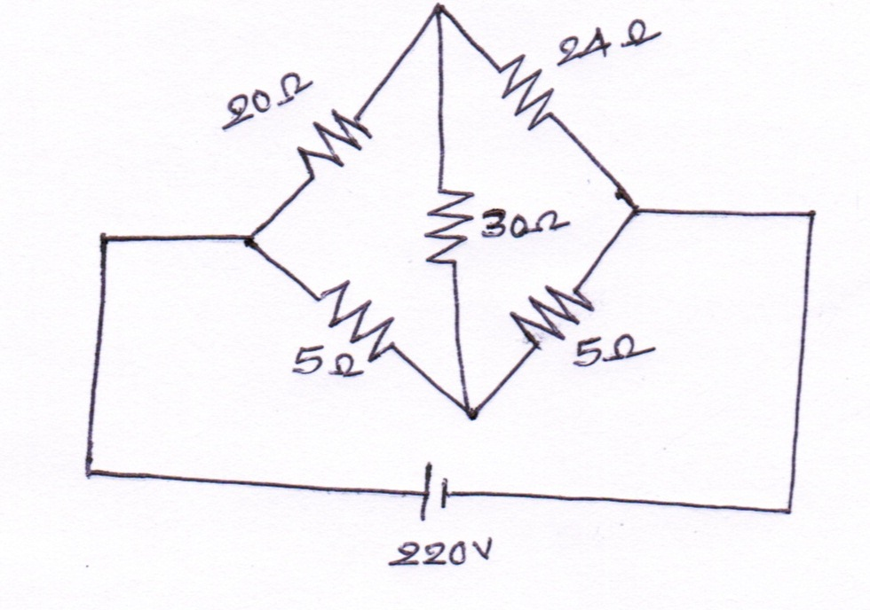

6. Find the voltage to be applied across AB in order to drive a current of 5A into the circuit.
10M
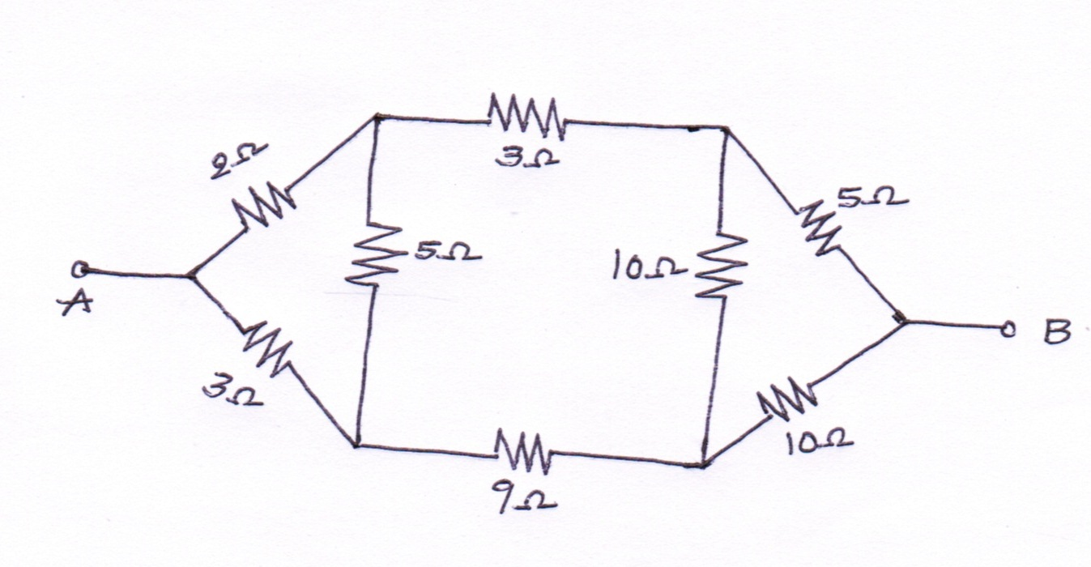
7.(a)Explain about basic circuit components in detail 6M
(b)Explain about KVL. 4M
8.Explain the following 10M
(a)Resistive networks
(b)Inductive networks
9. Explain the following 10M
(a)Resistive networks
(b)Capacitive networks
10.(a) Define RMS value, average value, form factor and peak factor. 4M
(b) Show the form factor of the sine current is 1.11./ Find form factor of the sine current. 6M

UNIT –II
Network theorems & Twoport networks
1(a).State super position theorem 2M
(b)Calculate the current in 2Ω resistor in the fig. using super position theorem. 8M
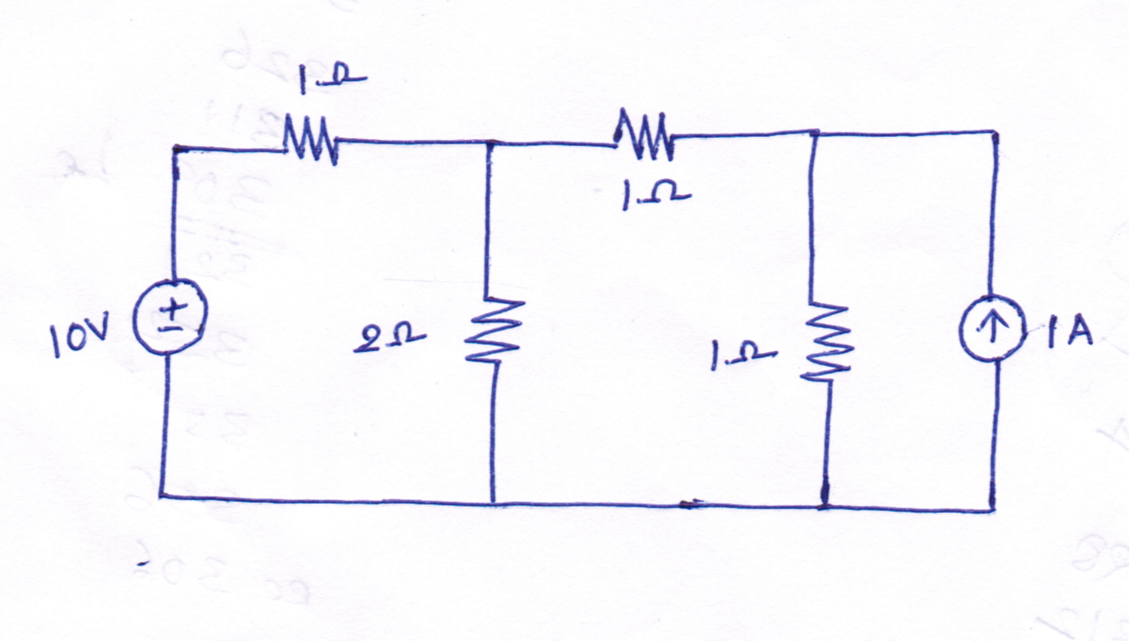
2(a).State Thevenins theorem 2M
(b) Find Thevinins equivalent circuit across AB for the circuit shown in below. 8M
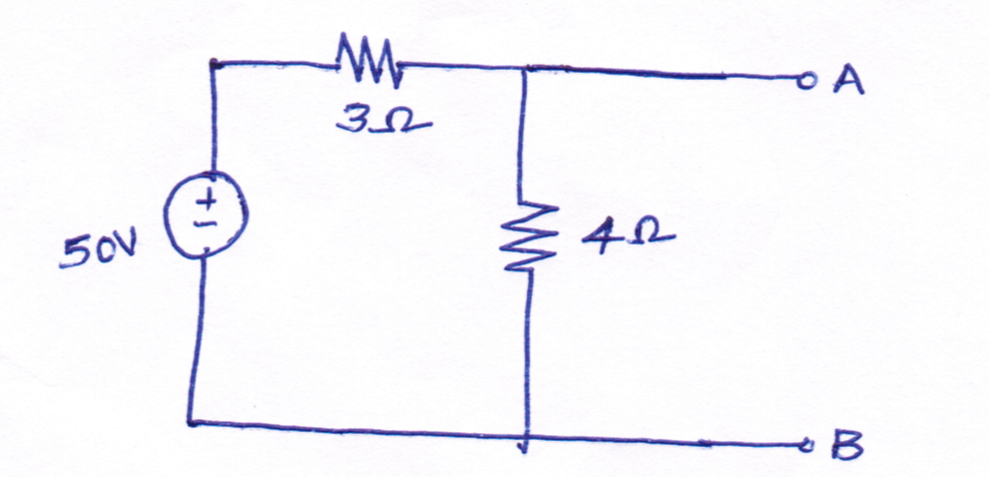
3(a).State Nortons theorem 2M
(b) Find Nortons equivalent circuit across AB for the circuit shown in below. 8M

4.Determine the maximum power delivered to the load in the circuit shown in fig. 10M

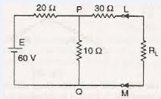
5.State and prove Reciprocity theorem with an example. 10M
6. (a) Define and explain about Impedance parameters. 5M
(b)Define and explain about Y- parameters 5M
7.Find the Open circuit parameters for the circuit shown in fig. 10M
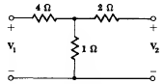
8.Find the Short circuit parameters for the circuit shown in fig. 10M

9.The given ABCD parameters are A=2,B=0.9,C=1.2,D=0.5 find Y- parameters. 10M
10.The given Y-parameters are Y₁₁=0.5,Y₁₂=Y₂₁=0.6,Y₂₂=0.9 find impedanace parameters 10M

UNIT –III
DC MOTORS and TRANSFORMERS
1.(a)Explain about principle of operation of DC Motors in detail. 6M
(b)Calculate the value of Torque established by the armature of a 4-pole motor having 774conductors,2 paths in parallel,24mwb flux per pole when the total armature current is 50A. 4M

2.A 220Vshunt motor takes a total current of 80A and runs at 800 r.p.m .Shunt field resistance and armature resistance are 50Ω and 0.1Ω respectively.If iron and friction losses amount to 1600W.find(i)Copper losses(ii)Armature torque(iii)Shaft torque(iv)Efficiency. 10M
3.(a)Derive Torque eqution of dc motor. 5M
(b)The counter emf of Shunt motor is 227 volts the field resistance is 160Ω and field current 1.5A if
the line current is 36.5A find the armature resistance also find armature current when the motor is
stationary. 5M
4.(a)Explain about constructional details of dc motor. 6M
(b)A 6 pole lap wound shunt motor has 500 conductors ,the armature and shunt field resistances are
0.05 Ω and 25 Ω respectively find the speed of the motor if it takes 120A from dc supply of 100V
flux per pole is 20mwb 4M
5. A 230Vshunt motor takes a total current of 70A and runs at 900 r.p.m .Shunt field resistance and
armature resistance are 40Ω and 0.2Ω respectively.If iron and friction lossesamount to
1700W.find(i)Copper losses(ii)Armature torque(iii)Shaft torque(iv)Efficiency. 10M
6. a) Derive EMF equation of a transformer. 5M
b) A 100KVA, 11000V/400V, 50Hz transformer has 40 secondary turns. Calculate the number
of primary turns and primary and secondary currents. 5M

7(a)Explain constructional details of transformer. 5M
(b) A 20KVA, 2000V/200V, 50Hz transformer has 66 secondary turns. Calculate the number
of primary turns and primary and secondary currents.Neglect losses. 5M
8. a) Explain OC and SC test of a single phase transformer. 5M
(b)A Single phase 2200/250V,50Hz transformer has a net core area of 36cm² and a maximum
flux density of 6wb/m².Calculate the number of turns of primary and secondary. 5M
9(a) Explain principle of operation of transformer. 5M
(b) An ideal transformer has 1000turns on its primary and 500 turns on its secondary the driving
voltage of primary side is 100V and the load resistance is 5 Ω,calculate V₂,I₁and I₂ 5M
10.(a)Explain principle of operation of transformer 5M
(b) Derive EMF equation of a transformer. 5M

.

PART-B
UNIT –I
SEMI CONDUCTORS
2 marks:
1. Define Doping. 2M
2. What do you understand by extrinsic semiconductor? 2M
3. What are the two types of extrinsic semiconductors? 2M
4. What is meant by unbiased PN junction? 2M
5. What is meant by depletion layer in unbiased PN junction? 2M
10 Marks:
1. Explain the operation of forward biased and reverse biased PN junction Diode. 10M
2. (i) Explain the current components in a PN junction diode. (ii) Derive the diode current equation. (5+5) 10M
3. Briefly explain about avalanche and zener breakdown. 10M
4. Explain the working of Bridge rectifier. Give the expressions for RMS current, PIV, ripple factor and efficiency. 10M
5. Draw the block diagram of series and shunt voltage regulator and explain the operation of series & shunt voltage regulator. 10M
6. (i)Describe the working of LC filter. (ii)Explain V-I characteristics of Zener diode. (5+5) 10M
7. (i) Briefly explain the operation of multiple LC filter.
(ii) Explain the operation of π section filter with bridge rectifier and also derive an expression for its stability factor. (5+5) 10M
8. (i) Explain about the switching characteristics of the diode.
(ii) Explain about the effect of temperature on diode characteristics. (5+5) 10M
9. (i) Draw the V-I characteristics of PN junction Diode.
(ii) Draw the V-I characteristics of Zener diode. (5+5) 10M
10. (i) Design a full wave rectifier with C filter for Vdc = 12 V; IL = 100 mA and ripple factor = 5%.
(ii) A 5V battery is connected across the two diodes connected in series opposing.
Find the voltage drop across each diode at room temperature. (5+5) 10M

UNIT –II
BJT
2 Marks:
1. What is transistor? Give its circuit symbol. 2M
2. In a transistor operating in the active region although the collector junction is reverse biased the collector current is quite large. Explain. 2M
3. What is reverse saturation current? 2M
4. Define α and β. 2M
5. What is meant by punch through effect? 2M

10 Marks:

1. Draw and explain the input and output characteristics of a transistor in CE configuration. 10M
2. (i) Explain the operation of Power transistor.
(ii) Describe two applications of BJT. (5+5) 10M
3. Draw and explain the input and output characteristics of a transistor in CB configuration. 10M
4. (i) Explain the working of NPN and PNP transistor.
(ii) With neat diagram, describe the principle and working of Optocoupler. (5+5) 10M
5. With necessary circuit and waveform, explain the switching characteristics of a transistor in detail. 10M
6. (i) Distinguish between the different types of transistor configurations with necessary circuit diagrams.
(ii) With neat sketch, explain low frequency and high frequency model of a transistor. (5+5) 10M
7. Draw and explain the input and output characteristics of a transistor in CC configuration. 10M
8. Derive the expression for AI, AV, Ri and Ro for CB amplifier using h-parameter model. 10M
9. Derive the equations for voltage gain, current gain, input impedance and output admittance for a BJT using low frequency h-parameter model for
(a) CE configuration (b) CB configuration and (c) CC configuration. (3+3+4) 10M
10. (i)The h-parameters of a transistor are given below. The source and load resistances of a CE amplifier are equal to 2 kΩ.Compute AV, Ri and RO.
(ii)If the common-emitter h –parameters of a transistor are given by hie = 2000 Ω ,hfe = 49, hre = 5.5x10-4 and hoe = 2.5x10-5, find the common base h-parameters of the transistor. (5+5) 10M

UNIT –III
JFET & MOSFET
2 Marks:

1. What are the features of JFET? 2M
2. What is meant by Pinch-off voltage? 2M
3. Define amplification factor. 2M
4. Draw the symbol of JFET. 2M
5. Define drain resistance and Transconductance. 2M

10 Marks:

1. Explain with the help of neat diagrams, the structure of an N-channel FET and its Volt-ampere characteristics. In what ways it is different from a bipolar transistor. 10M
2. Describe the construction and explain the operation of depletion mode
MOSFET. Also draw the static characteristics. 10M
3. Explain the working of a P channel JFET and draw the V-I characteristics of it. 10M
4. (i)Compare N-with P-channel MOSFETS. (ii)Compare P-channel JFET with N-channel JFET. (5+5) 10M
5. (i)Compare JFET and MOSFET?
(ii)With neat diagram, explain the working of Darlington connection. (5+5) 10M
6. (i) Draw and explain the small signal model of common drain amplifier. (ii) Draw and explain the small signal model of common gate amplifier. (5+5) 10M
7. Describe the kind of operation that takes place in the enhancement mode
MOSFET. How does this differ from depletion mode type? 10M
8. (i) Draw and explain the small signal model of common source amplifier. (ii) Write short notes on threshold voltage and gate capacitance. (5+5) 10M
9. (i) Explain the performance of FET as a voltage variable resistor
(ii) Define and explain the three parameters of a JFET give the relation between them. (5+5) 10M
10. (i) Show that if a FET is operated at sufficiently low drain voltage, it behaves as a resistance R given by R = R0 / [1- (VGS / VP)1/2] Where R0 is the channel resistance for zero gate voltage.
(ii) Obtain low frequency and high frequency model for FET. (5+5) 10M

